EXP 4
DML COMMANDS – UPDATE ,DELETE
- UPDATE
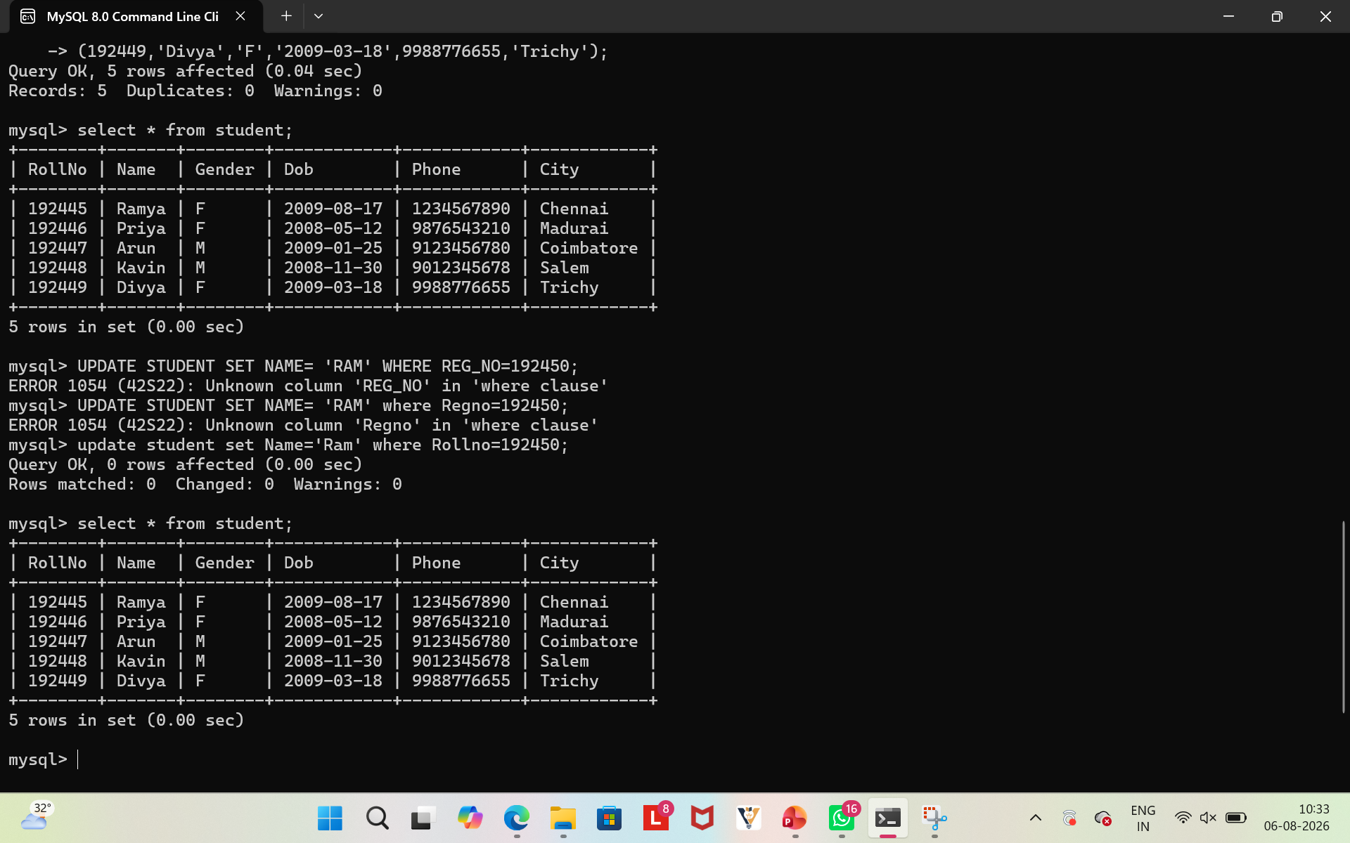
- DELETE
